
VENTURE CREATION · GSLC ASSIGNMENT · CUSTOMER DISCOVERY
Prototype Testing Report & Feedback Grid
Faunora: pet diet consultation & in-house catering
Name | Student ID (NIM) | Role
Siegfried Vesakha Setiawan | 2802405882 | CEO
Kayne Deron Kusnadi | 2802405150 | COO
Angelino Delvin | 2802526271 | CFO
Andi Siti Maryam Shaskirana | 2802462500 | CMO

BINUS University · October 2026

Contents
1. Executive Summary 3
2. Background and Objectives 3
2.1 Hypotheses 3
3. The Prototype 4
4. Method 7
4.1 Participants 7
4.2 Session structure (30 minutes) 7
4.3 Tasks 8
4.4 Metrics 8
5. Results 8
5.1 Task performance 8
5.2 Usability score 9
5.3 Price and purchase intent 9
6. Key Findings 10
6.1 Usability issues 11
7. Feedback Grid 12
8. From Feedback to Action 12
9. Next Experiment: Concierge MVP 13
Appendix A. Moderator Script (summary) 13
Appendix B. System Usability Scale Items 13

1. Executive Summary
This is a simulated customer-discovery study prepared for the GSLC assignment. Participants, quotes and numbers are realistic assumptions that illustrate the method, not real data. They should be replaced with results from real sessions.

We tested the Faunora website prototype with 12 dog and cat owners in Jabodetabek to learn whether people understand and want our two core services, diet consultation with professional nutritionists and homemade catering from our own kitchen, and whether they can use the prototype without help.
Headline result | Value | What it means
Understood the offer within 10 seconds | 10 / 12 (83%) | The "consult, then we cook" idea is clear
Average task success | 88% | Prototype is usable; one task needs work
System Usability Scale (SUS) | 78.3 | Above the 68 benchmark ("good")
Would probably or definitely book within 3 months | 7 / 12 (58%) | Promising purchase intent
Faunora prices inside the acceptable range | 3 / 3 offers | Pricing is credible
Raised delivery freshness as a concern | 7 / 12 | New risk to address in design

Biggest improvement needed: finding food that fits a specific health need (67% success). Biggest new insight: owners worry about freshness in Jakarta traffic before they worry about price.

2. Background and Objectives
After our professor's consultation, Faunora pivoted from a broad pet-care platform (Peybo) to two focused services. Before investing in a kitchen and a nutritionist network, we needed evidence that customers value this focus. The prototype test had four objectives:
- Check that owners understand Faunora as consultation + our own kitchen, not a marketplace.
- Measure whether they can book a consultation and find plan-suitable food without help.
- Learn what makes them trust a nutritionist's recommendation.
- Estimate an acceptable price range for consultations and monthly meal plans.

2.1 Hypotheses
# | We believe that… | Test | Pass if | Result
H1 | Pet owners understand the consult-then-cook concept quickly | T1: explain the site in 10 s | ≥ 75% correct | 83%: Validated
H2 | Owners trust plans only from licensed experts | Think-aloud during T2 | ≥ 60% mention credentials | 75%: Validated
H3 | Owners can find food for their pet's need unaided | T3 task success | ≥ 80% | 67%: Not validated
H4 | Our prices are acceptable | Price-range questions | Price within median range | 3 of 3: Validated
H5 | Owners intend to buy | Purchase-intent question | ≥ 50% "probably/definitely" | 58%: Validated
H6 | Delivery freshness is not a major concern | Unprompted mentions | ≤ 3 of 12 raise it | 7 of 12: Invalidated

3. The Prototype
We tested a high-fidelity, clickable, responsive website (HTML/CSS/JavaScript) that runs locally on desktop and mobile. Booking and checkout are simulated, but every screen and interaction works: consultation booking, the catering timeline, the shop with an animated add-to-bag, the bag drawer, reviews, the story and the team.
Prototype area | What participants could do
Home | Read the value proposition; jump to consultation or shop
Diet consultation | Compare three nutritionists, view prices, submit a session request
Catering | See how meals are sourced from local farmers and cooked in our kitchen (6-step timeline)
Shop | Filter by category (meals, snacks, toys, fashion), add items to the bag
Bag | Change quantities, see subtotal, start checkout (simulated)
About, History, Team | Read the brand story and meet the founders

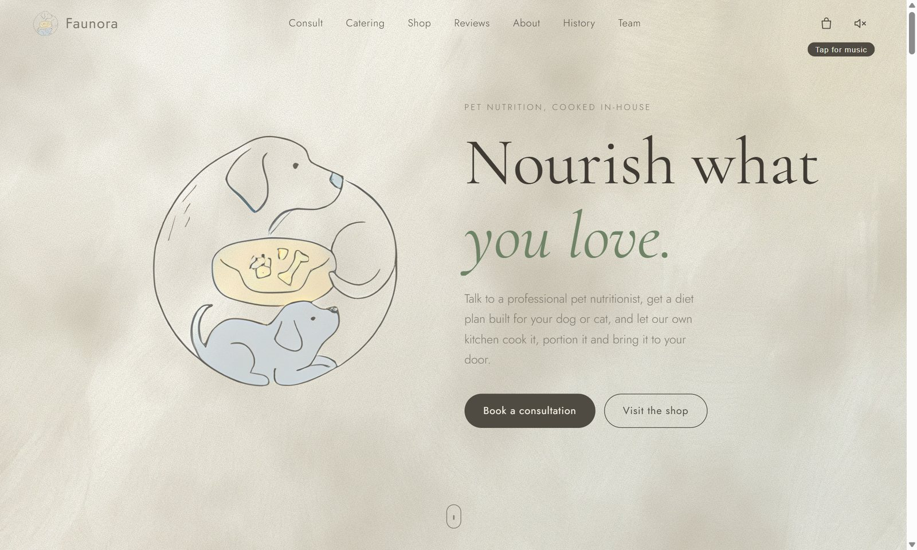
Figure 1. Prototype home page (desktop).
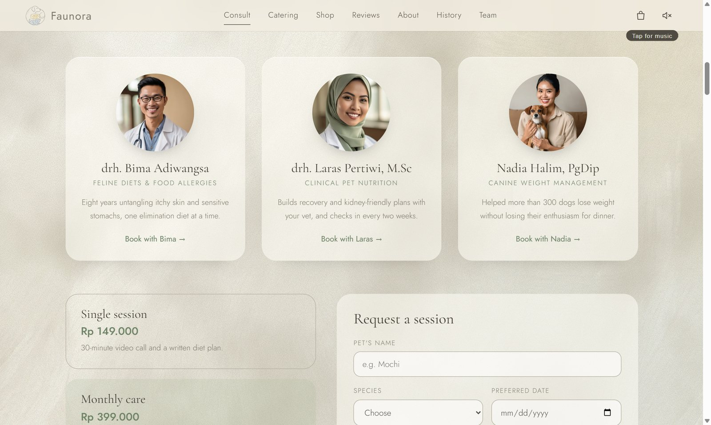  Figure 2. Nutritionist profiles and booking. | 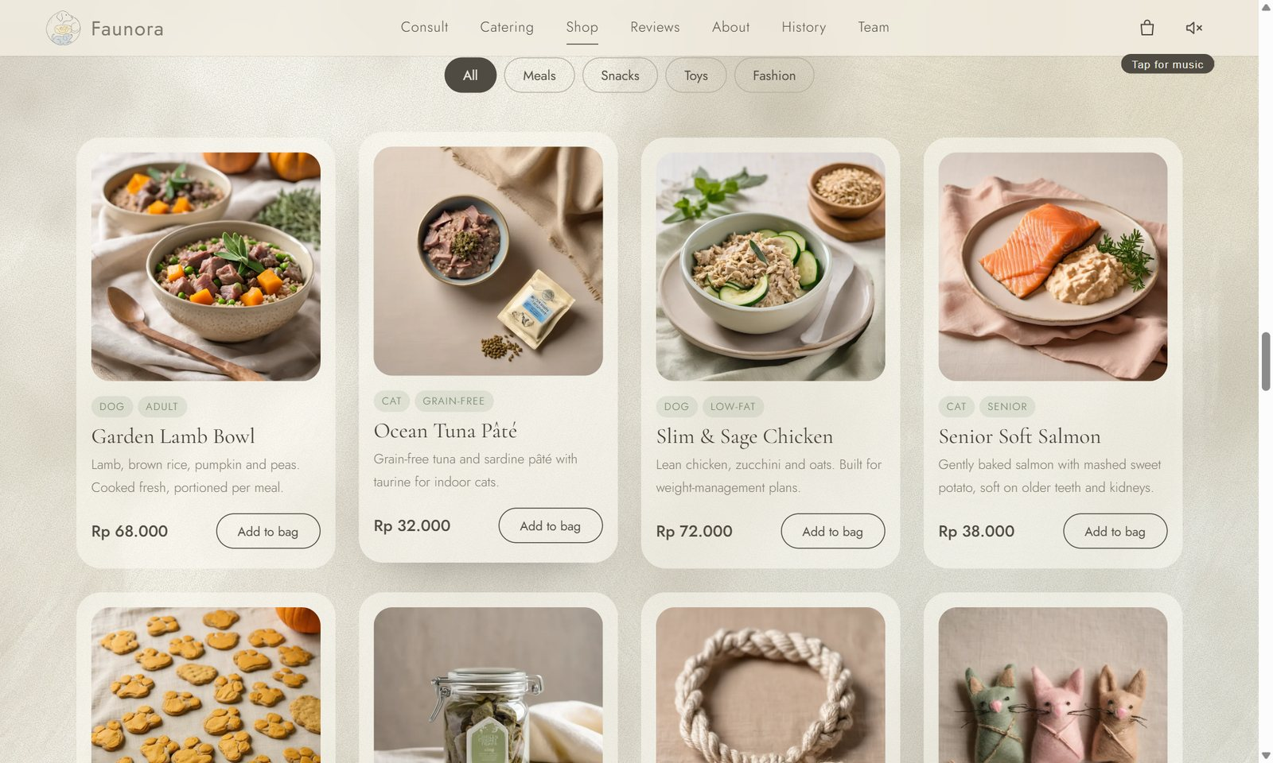  Figure 3. In-house shop with animated add-to-bag.

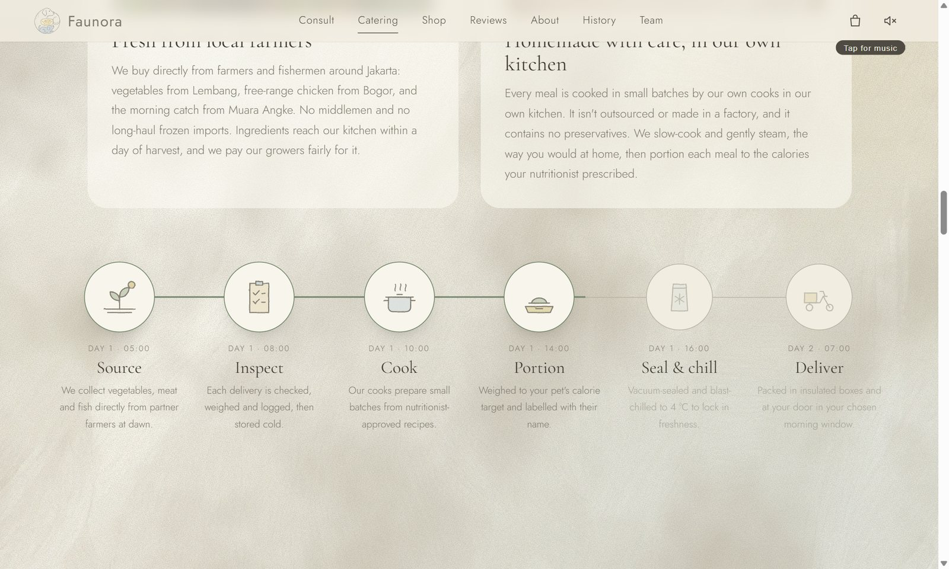
Figure 4. Catering timeline: the line fills and each step lights up as the visitor scrolls.
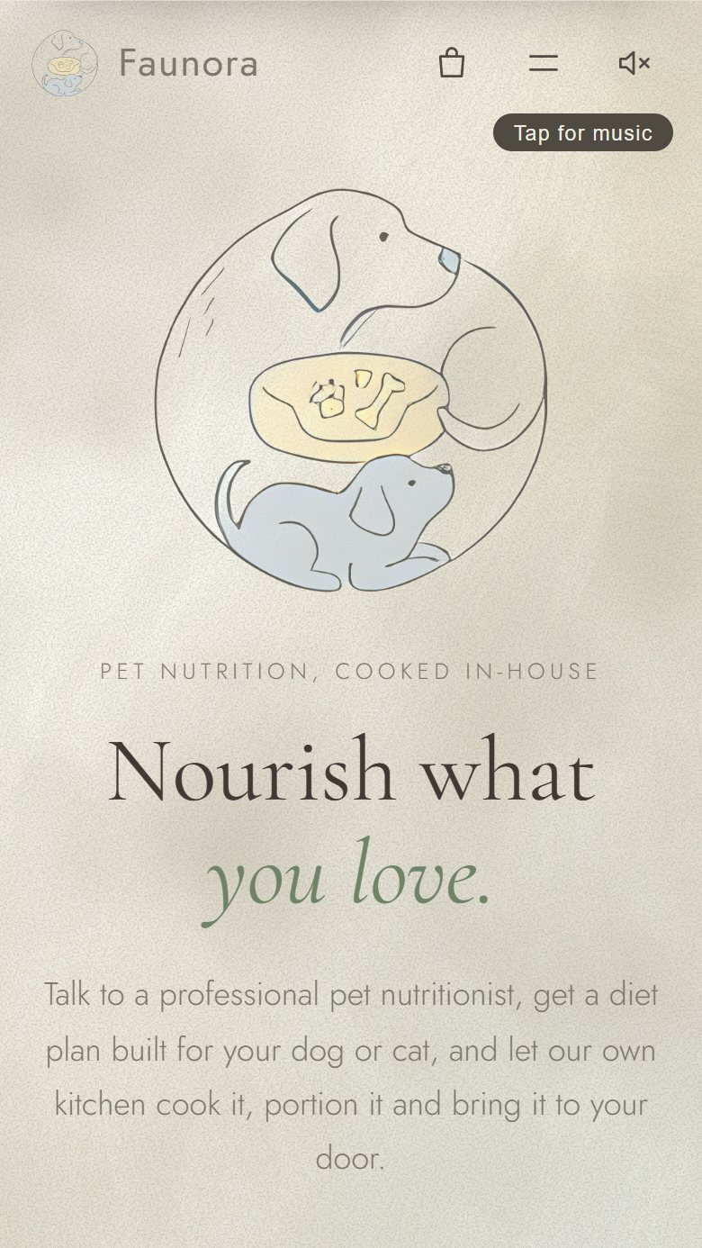  Figure 5. Mobile home page. | 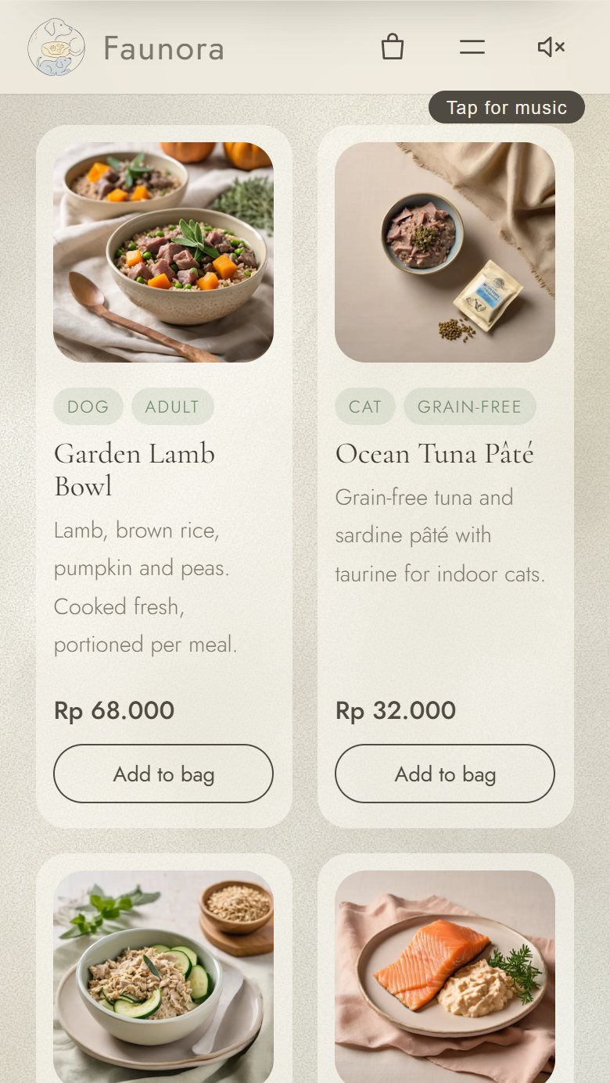  Figure 6. Mobile shop.

4. Method

4.1 Participants
Twelve owners were recruited through campus groups, Instagram pet communities and two pet shops in South and West Jakarta. We deliberately included the special-diet niche (overweight, allergic, senior and recovering pets) because it is our priority segment.
ID | Age | Pet(s) | Situation | Segment
P1 | 24 | Cat (2 y) | Student, lives in a kos | Budget owner
P2 | 29 | Golden Retriever (6 y), overweight | Office worker | Special diet
P3 | 33 | 2 cats, one with food allergy | Graphic designer | Special diet
P4 | 27 | Shih Tzu (3 y) | Office worker | General health
P5 | 38 | Mixed-breed dog (11 y) | Parent, two kids | Senior pet
P6 | 22 | Cat (1 y) | Student | Budget owner
P7 | 31 | Beagle, recovering from surgery | Entrepreneur | Recovery
P8 | 26 | 3 cats | Content creator | Multi-pet
P9 | 35 | Pomeranian (4 y) | Nurse, shift work | Busy owner
P10 | 28 | Persian cat, sensitive stomach | Office worker | Special diet
P11 | 41 | 2 Labradors | Business owner | Premium
P12 | 25 | Domestic cat (5 y) | Fresh graduate | General health

4.2 Session structure (30 minutes)
Time | Activity
0–3 min | Welcome, consent, explain think-aloud
3–20 min | Five tasks on the prototype (desktop or own phone)
20–24 min | System Usability Scale questionnaire (10 items)
24–30 min | Interview: trust, price range, purchase intent, open feedback

4.3 Tasks
Task | Scenario given to the participant | Success criterion
T1 | "Look at this page for 10 seconds. What does this company do?" | Mentions both consultation and cooked meals
T2 | "Book a session with a nutritionist for your pet." | Form submitted with correct pet details
T3 | "Your pet needs to lose weight / has an allergy. Find a suitable meal and add it to your bag." | Correct product in bag
T4 | "Change the quantity to 2 and tell us the subtotal." | Correct subtotal stated
T5 | "Find out who is behind Faunora." | Reaches the team section

4.4 Metrics
- Task success rate and time on task.
- Single Ease Question (SEQ), 1–7, after each task.
- System Usability Scale (SUS), 0–100, benchmark 68.
- Price range using Van Westendorp questions ("too cheap to trust", "expensive but acceptable", "too expensive").
- Purchase intent on a 5-point scale.

5. Results

5.1 Task performance
Task | Success | Average time | SEQ (1–7)
T1 Understand the offer | 10/12 (83%) | 9 s | n/a
T2 Book a consultation | 11/12 (92%) | 58 s | 6.1
T3 Find a suitable meal & add to bag | 8/12 (67%) | 1 min 42 s | 4.6
T4 Edit the bag | 12/12 (100%) | 21 s | 6.6
T5 Find the team | 12/12 (100%) | 14 s | 6.8

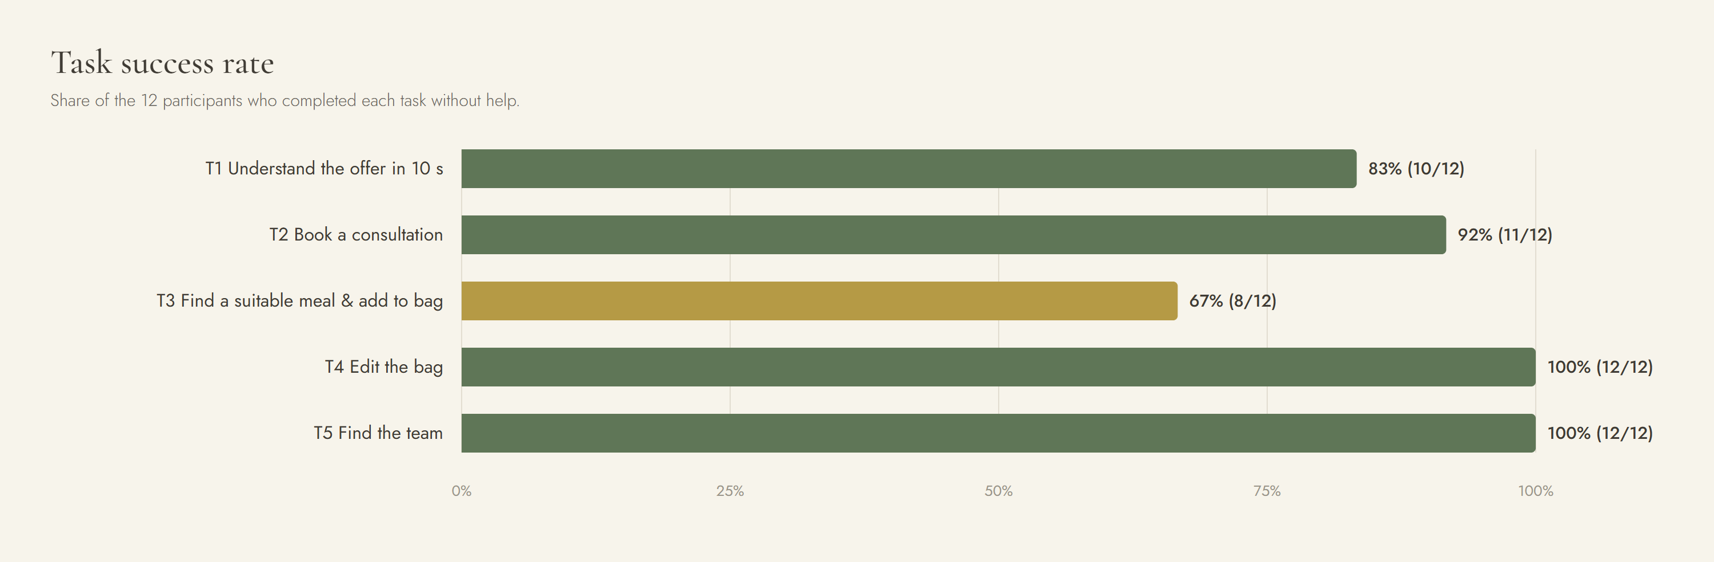
Figure 7. Task success rate. T3 (highlighted) is the only task below the 80% target.

5.2 Usability score
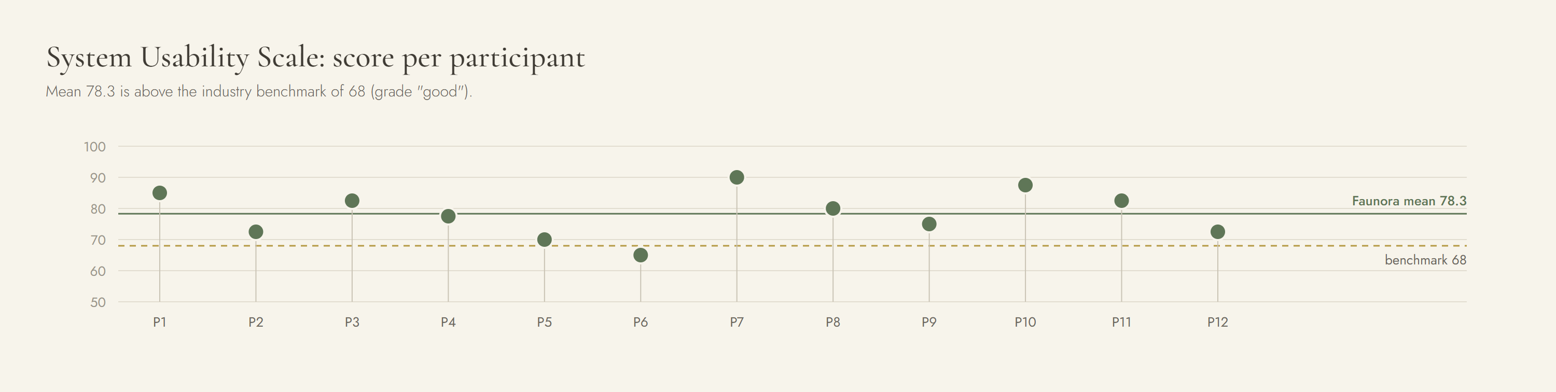
Figure 8. SUS score per participant. Only P6 scored below the benchmark.

5.3 Price and purchase intent
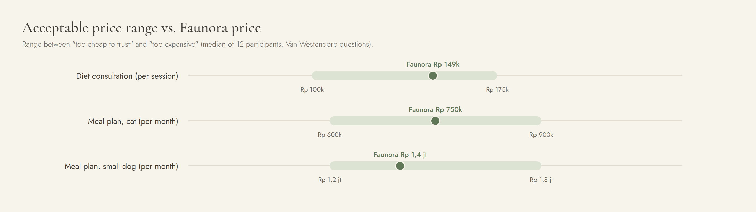
Figure 9. Acceptable price range per offer, with Faunora's planned price.
Purchase intent (book within 3 months) | Participants
Definitely | 3
Probably | 4
Not sure | 3
Probably not | 2
Definitely not | 0

6. Key Findings

F1. "Consult, then we cook" is clear and valued
10 of 12 explained the concept correctly within 10 seconds. Special-diet owners responded most strongly.
"So the nutritionist decides, and you cook it? That is exactly what I need. I don't trust myself with portions." P2, owner of an overweight Golden Retriever

F2. Trust comes from credentials, not design
9 of 12 looked for the "drh." title or asked about licences before booking. Several wanted to see education and years of practice.
"If it says drh., I believe it more. I want to know where they studied." P3

F3. Finding the right food is the weakest step
The shop filters by category, not by health need. Four participants scrolled the whole grid reading tags; two added a product that did not fit their pet's condition.
"I have to read every card to find 'sensitive stomach'. Can't it just show me what my cat can eat?" P10

F4. Freshness worries come before price
7 of 12 asked, without prompting, how the food stays fresh in Jakarta traffic and who receives it when they are out. The catering timeline helped, but people wanted explicit guarantees.
"I work shifts. If the box sits outside for two hours, is it still safe?" P9

F5. The homemade, local-farm story builds confidence
Participants who reached the catering section described the food as "real", "like home cooking" and "not factory food". Local farm sourcing was seen as a quality signal.

F6. The calm, illustrated design feels premium
8 of 12 called the site "calm", "premium" or "cute but serious". The add-to-bag animation was noticed and liked. Two participants were surprised by the background music but found the mute button immediately.

F7. The honest "five-minute" origin story is likeable
Half of the participants laughed at the history section. P11 asked whether it hurts credibility; most felt the nutritionist section balances it.

F8. Price sensitivity depends on the segment
Students (P1, P6) preferred snacks and a single consultation. Special-diet owners (P2, P3, P7, P10) saw the monthly plan as good value compared with vet bills.

6.1 Usability issues
# | Issue | Severity | Recommendation
U1 | No way to filter products by health need | 3 · Major | Add "Shop by need": weight, allergy, senior, recovery
U2 | Consultation result does not carry into the shop | 3 · Major | After a session, show "Your plan" with matching meals pre-selected
U3 | Delivery area, schedule and freshness not explained | 3 · Major | Delivery FAQ, area checker, cold-chain guarantee near the bag
U4 | Nutritionist credentials too brief | 2 · Minor | Expandable profile: education, licence number, years of practice
U5 | Background music surprised some users | 1 · Cosmetic | Play only after the first interaction; keep the mute button visible (done)
U6 | No size guide for clothing | 1 · Cosmetic | Size chart by weight and breed

7. Feedback Grid
The Feedback Capture Grid summarises everything we heard in four quadrants.
+ What worked  - Clear core idea: "a nutritionist plans it, Faunora cooks it" (83% understood in 10 s)  - Licensed nutritionists (drh.) create trust  - Homemade cooking and local-farm sourcing feel genuine  - Calm, artistic design feels premium and friendly  - Short, easy booking form (SEQ 6.1)  - Smooth add-to-bag animation and clear bag feedback  - Honest, funny origin story makes the brand likeable  - One in-house shop feels safer than a marketplace | △ Needs improvement  - No "shop by health need" filter; T3 took too long  - Consultation plan is not linked to the shop  - Delivery area, schedule and freshness are not explained  - Expert profiles need education and licence details  - Monthly plans feel expensive for students  - Music autoplay surprised two users  - No size guide for fashion items
? Questions raised  - How long does food stay fresh in heat and traffic?  - Who receives the box if I'm not home?  - Where did the nutritionists study? Are they licensed?  - Can the plan change if my pet dislikes the food?  - Is it safe alongside my vet's medication?  - Can I pause my subscription when I travel?  - Do you deliver outside Jakarta? | ★ New ideas  - "Shop by need" filter: weight, allergy, senior, recovery  - Starter Trial Box: 3 days of meals + discounted consultation  - Taste-test sachets before subscribing  - Feeding calendar and WhatsApp reminders  - Student plan: snacks + one consultation per quarter  - Monthly weigh-in with a progress chart  - Smart cooler box or pick-up points for people who are out  - Referral partnership with vet clinics

8. From Feedback to Action
Priority | Action | Addresses | Owner | When
High | Build "Shop by need" filter and link the consultation plan to the shop | U1, U2, H3 | COO · Kayne | Sprint 1
High | Delivery FAQ, area checker and cold-chain guarantee; run the L9 packaging test | U3, H6 | COO · Kayne | Sprint 1–2
High | Detailed nutritionist profiles with licence numbers | U4, F2 | CMO · Andi | Sprint 1
Medium | Price and margin model for the Starter Trial Box and a student plan | F8 | CFO · Angelino | Sprint 2
Medium | Subscription pause/skip and pick-up points | Questions | CEO · Siegfried | Sprint 3
Low | Fashion size guide | U6 | CMO · Andi | Sprint 3

9. Next Experiment: Concierge MVP
The prototype validated interest and usability. It could not validate retention or the cold chain. Next, we will run a 4-week concierge pilot:
Item | Plan
Participants | 5 dogs and 5 cats, at least half from the special-diet niche
Service | Real consultation with a licensed vet; meals cooked in a rented kitchen; delivered by the team twice a week
Price | Pilot discount of 30% to reduce risk for participants
Measures | Handover temperature, delivery delay, plan adherence, weight change, renewal intent
Success criteria | All deliveries ≤ 5 °C; ≥ 85% adherence; ≥ 6 of 10 willing to renew at full price

Appendix A. Moderator Script (summary)
- "Thank you for helping. We are testing the website, not you. There are no wrong answers."
- "Please think out loud: tell us what you are looking at and what you expect to happen."
- Give tasks T1–T5 one at a time; do not help unless the participant is stuck for 2 minutes.
- After each task: "How easy was that, from 1 (very hard) to 7 (very easy)?"
- SUS questionnaire, then the price-range and purchase-intent questions.
- "What would make you trust Faunora with your pet's food? What would stop you?"

Appendix B. System Usability Scale Items
- I think that I would like to use this website frequently.
- I found the website unnecessarily complex.
- I thought the website was easy to use.
- I think that I would need help to be able to use this website.
- I found the various functions in this website were well integrated.
- I thought there was too much inconsistency in this website.
- I would imagine that most people would learn to use this website very quickly.
- I found the website very cumbersome to use.
- I felt very confident using the website.
- I needed to learn a lot of things before I could get going with this website.

